**DEPARTMENT OF INFORMATION TECHNOLOGY**



***Synopsis of Mini Project On***

ONLINE EXAM MANAGEMENT SYSTEM

Prepared By:

Adwait Jedhe (Roll No. 23)

Ansh Mehta (Roll No. 32)

Anish Charak (Roll No. 7)

Under the guidance of:

Prof. Nasim Shah

**Department of Information Technology**

**Academic Year: 2021-2022**

**Autonomy Syllabus Scheme-I (2021-22) - SEMESTER III (SY - IT)**

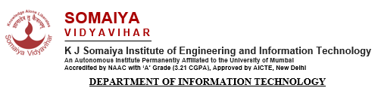

**CERTIFICATE**

## This is to certify that following students:

Roll No. / Seat No.

Adwait Jedhe 23

Ansh Mehta 32

Anish Charak 7

have submitted PBL – Mini Project I Report on *“Online Exam Management System”* as the partial fulfillment for the requirement of Second Year of Engineering (3rd Semester) in S.Y. - Information Technology under my guidance during the academic year 2021-2022.

|  |  |
| --- | --- |
| ***Mrs. Nasim Shah*** | **Dr. Radhika Kotecha** |
| **Project Guide** | **Head of Department** |
| **Assistant Professor** | **Associate Professor** |
| **Department of Information Technology** | **Department of Information Technology** |

### 

**Date of Examination: _________________**

**Signature of Internal Examiner Signature of External Examiner**

**Table of Contents**

|  |  |
| --- | --- |
| Acknowledgement | ii |
| Abstract | iii |
| 1. Introduction    1. Motivation    2. Problem analysis    3. Objectives    4. Future scopes | 1  1  2  2  2 |
| 1. Literature Review    1. Related Work    2. Existing System | 4  4  4 |
| 1. Proposed System    1. Proposed approach and details    2. Innovation in Idea    3. Timeline | 6  6  8  8 |
| 1. Implementation Details and Results    1. Technology stack    2. Preliminary results 2. Conclusion 3. References | 10  10  12  22  23 |

i

**Acknowledgement**

The satisfaction which accompanies successful completion of any task would be incomplete without the mention of people whose ceaseless cooperation made it possible, whose constant guidance and encouragement crown all efforts with success.

We convey our thanks to our project guide *Mrs. Nasim Shah* of Information Technology Department for guiding us in the mini project throughout numerous consultations. We are indebted to our inspiring HOD *Dr. Radhika Kotecha* and Project Guide Mrs. Nasim Shah who extended all valuable guidance, help and constant encouragement through various difficult stages for the development of the project. We express our sincere gratitude to our respected Principal *Dr. Suresh Ukarande* and Vice-Principal *Dr. Sunita Patil* for encouragement and facilities provided to us. We are obliged and we convey our thanks to the teaching as well as the non-teaching staff of the department.

ii

**Abstract**

Computers are known for their wide range of uses especially in scientific and mathematical fields. However little or no thought has been given to designing a complete and thorough intelligence Online examination on a computer system in our immediate environment. This Online examination system is designed to assist university in administration and smooth conduction of examination. The design of the system is quite simple and easily understood. Its flexibility makes it amenable for future changes and amendment to either incorporate other aspects of intelligence or to be designed for any other school, age or class. The question of the online examination system is programmed and visually displayed on the system’s screen in an interactive form. The student answers the question on the computer system, immediately the question is marked and notified. The result of this online examination is also displayed at the end of the examination which goes a long way to lessen the fears of students that they were marked down in the examination. Since the Online examination is examined by the computer, time cost of manual examination is saved and based on the virtues of internet amendment which have been made to the examination system concept by constructing a website with online examination, online question and answer setting and updation of questions and online management by the administrator.

iii

**Chapter 1: Introduction**

Examination Management System is a software developed for the students who give exams in colleges and institutes. It facilitates the access to examination information of a particular student in a particular class to the teacher making it simpler for the teacher to store and retrieve student examination information. The information is sorted by the operators, which will be provided by the teacher for a particular class. This system will also help the teacher to sort the student data according to the marks scored by them, either in ascending order or in descending order or randomly selectinf a score and arranging the data.

* 1. **Motivation**

Due to the inconsistency which have persisted in entrance examination system through the university administration system and neighboring institutions. The justification for this work is as follows: To do away with manual method of paper and pen for online examination which have posed serious threat to the standard of student ability during exams. The manual method could not handle the problem of sorting, problem of online examination and tutor-marked exam malpractice during exams as result an efficient method has to be put in place to eradicate the possibility of occurrence in the system. An on-line examination system helps to reduce the fears of student thinking they were mark down during the manual exams. To save cost of constant purchase of answer booklets and also save time and human labor of strolling round the exams to checking for student irregular act in the exam hall, malpractices etc. Online examination student can easily write their exam anywhere around the globe once they purchase the school scratch card for the examination.

* 1. **Problem Analysis**

Despite advances in technology, today's blood bank systems are running in manual system.

As such, there is a prevalent problem in the availability of needed blood types. For instance,

when a person needs a certain type of blood and this type is not available in the hospital, family

members send messages through social media to those who can donate to them and this process

takes longer than the life of the patient to the most dangerous. In addition, it seems that there is

lack of proper documentation about blood donors and its medical history. This may lead to blood

bag contamination and may affect the blood transfusion safety.

Generally, this study aims to determine how the use of online bank management system

enhance blood transfusion safety.

Despite advances in technology, today's blood bank systems are running in manual system.

As such, there is a prevalent problem in the availability of needed blood types. For instance,

when a person needs a certain type of blood and this type is not available in the hospital, family

members send messages through social media to those who can donate to them and this process

takes longer than the life of the patient to the most dangerous. In addition, it seems that there is

lack of proper documentation about blood donors and its medical history. This may lead to blood

bag contamination and may affect the blood transfusion safety.

Generally, this study aims to determine how the use of online bank management system

enhance blood transfusion safety.

Despite advances in technology, today's blood bank systems are running in manual system.

As such, there is a prevalent problem in the availability of needed blood types. For instance,

when a person needs a certain type of blood and this type is not available in the hospital, family

members send messages through social media to those who can donate to them and this process

takes longer than the life of the patient to the most dangerous. In addition, it seems that there is

lack of proper documentation about blood donors and its medical history. This may lead to blood

bag contamination and may affect the blood transfusion safety.

Generally, this study aims to determine how the use of online bank management system

enhance blood transfusion safety.

Despite advances in technology, today's blood bank systems are running in manual system.

As such, there is a prevalent problem in the availability of needed blood types. For instance,

when a person needs a certain type of blood and this type is not available in the hospital, family

members send messages through social media to those who can donate to them and this process

takes longer than the life of the patient to the most dangerous. In addition, it seems that there is

lack of proper documentation about blood donors and its medical history. This may lead to blood

bag contamination and may affect the blood transfusion safety.

As much as most local institutions of learning have embraced E-learning to raise the bar and so as to cope with the ever-growing number of learners (students) very few institutions have adopted an online examination system, in fact little has been done in development of online systems. A lot of resources (time and money) are wasted since students have to move from place to place to do exams. Time and men power is also wasted as setting and marking of the exams is done manually. The purpose of online exam system is to take online test in an efficient manner and no time wasting for checking the paper.

The main objective of online test simulator is to efficiently evaluate the candidate thoroughly through a fully automated system that not only saves lot of time but also gives fast results. For students they give papers according to their convenience and time and there is no need of using extra thing like paper, pen etc.

* 1. **Objectives**

a) General Objective:

The general objective of Online Examination System is to create a platform for online creation, actual sitting and marking of exams.

b) Specific Objectives

i) Enables the Admin to create subjects to be undertaken by students.

ii) Enables the Admin to create Test conductors.

iii) Enables the Admin to create students.

iv) Enables the Test conductors to create subjects to be undertaken by students.

v) Enables the Admin to create tests to be undertaken by students.

vi) Enables the Test conductors to create tests to be undertaken by students.

vii) Enables the Admin to create Questions to be undertaken by students.

viii) Enables the Test conductors to create Qudtions to be undertaken by students.

ix) Enables the Admin to manage exam results.

* 1. **Scope**

Methodology of the system is clear that result in the complete and proper working of the system from the requirements achieved. it contains the working model for the development of system. A sequential step of model is followed to develop the system so that it will maintain various software engineering features/parameters. No need to take leave, visit a different town, city or even states in some cases. People can appear right from their laptop or home desktop.

**Chapter 2: Literature Review**

* 1. **Related Work**

A literature review revealed research and studies based on implementation of a variety technologies in college courses. “The internet has opened many possibilities for the classroom instruction but it can also be a barrier to teaching as well” (Bugeja, 2006). The new innovative technologies provide opportunities to improve learning and create a more exciting and motivating environment (Connors, 2007). According to a case study by Ralph, Buskirk, and Schmidt (2007) regarding the use of online projects, students in favour of online projects indicated that the accessibility to the professor for fast and easy feedback was a great asset. Furthermore, the study revealed that when implementing technology students were concerned with the expense of the technology, the necessity for internet access, and the reliability of the technology. Research on student perceptions and satisfaction with online courses provide insights to student reactions and satisfaction with implementation of an online exam. Hale (2007) found that student satisfaction surveys reveal that the most important reason for taking a distance education course is its convenience. In addition, Steinman (2007) indicated that “students’ perceptions of online courses can be negative if they experience large transactional distance with the instructor and with other students and can influence whether a student will stay in or drop out of a class.”

**Existing System**

The whole process of assigning test and evaluating their scores after the test, was done manually till date. Processing the test paper i.e., checking and distributing respective scores used to take time when the software was not installed. Teachers had to manually write the questions take their printouts and if the question had to be updated then they had to repeat the entire procedure again which is very time consuming and tiresome.

Also, when the examination is being held offline, a lot of other stationary materials are required, which has to be managed and taken care of which increases the botheration of teachers. The teachers had to manually correct each and every answer of sheet of students and give marks to each one of them separately which created a lot of workload on them.

Disadvantages of Current System:

•The current system is very time consuming.

•To take exam of more candidates more invigilators are required but no need of invigilator in case of online examination.

•The chances of paper leakage are more in current system as compared to proposed system.

•Result processing takes more time as it is done manually.

**Chapter 3: Proposed System**

**3.1 Proposed Approach and Details**

The system created for taking online examination has following features:

•In comparison to the present system the proposed system w be less time consuming and is more efficient.

•Result will be very precise and accurate and will be declared in very short span of time because calculation and evaluations are done by the simulator itself.

•The proposed system is very secure as no chances of leakage of question paper as it is dependent on the administrator only.

•The logs of appeared candidates and their marks are stored and can be backup for future use.

Scope of Proposed System:

Scope of this project is very broad in terms of other manually taking exams.

Few of them are:

1. This can be used in educational institutions as well as in corporate world.

2. It is easy to use, secure, reliable and accurate.

3. Can be used anywhere, any time as it is a web-based application (user location doesn’t matter).

4. No restriction that examiner has to be present when the candidate takes the test.

**3.2 Innovation in Idea**

Along with the features of the existing examination systems, we have included various other features and components to make it more user friendly. Some notable innovations in this idea are:

* *Student and Admin Login:* We have created two different logins for students and teachers respectively. Both the logins have been provided with different functionalities.
* *Flexibility in setting the Question Paper:* A teacher has full freedom to add questions and update them as and when they want.
* *Timer:* A timer is also set during the examinations within which the student has to finish the paper.
  1. **Timeline**

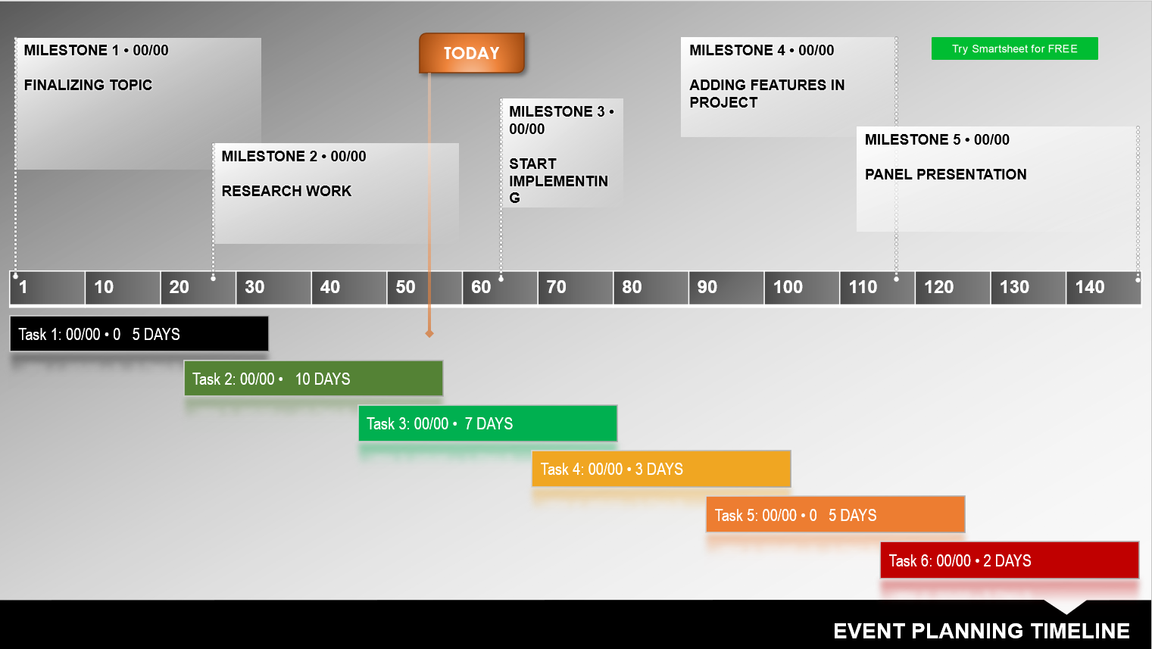

**3.4 Roles and Responsibilities**

* We worked together in researching the topic, finalizing the features of application, designing the User Interface (UI) and initializing the database.
* The team together worked on the Frontend part of the project with suggestions and discussions involving everyone in the team.
* Inputs and contributions were made by everyone in the team in preparing the presentations and reports of the project.
* We worked together as a team in making the entire mini project more user-friendly and as useful as it can be and completed the finalization of Frontend and Backend parts along with all the documentations and presentations.
* We as a team tried our very best to put out quality product and we hope to have done some value addition.

**Chapter 4: Implementation Details and Results**

**4.1 Technology Stack**

In the making of the “Exam Management System” java application Some of the major softwares used in this project are:

**Java Development Kit (JDK)**

The Java Development Kit (JDK) is a distribution of Java Technology by [Oracle Corporation](https://en.wikipedia.org/wiki/Oracle_Corporation). It implements the Java Language Specification (JLS) and the Java Virtual Machine Specification (JVMS) and provides the Standard Edition (SE) of the Java Application Programming Interface (API). The Java Development Kit (JDK) is a software development environment that offers a collection of tools and libraries necessary for developing Java applications. You need the JDK to convert your source code into a format that the Java Runtime Environment (JRE) can execute.



**MYSQL**

MySQL is a fast, easy-to-use RDBMS being used for many small and big businesses. MySQL is developed, marketed and supported by MySQL AB. Database from MySQL is linked to the NetBeans project through JDBC. JDBC is an acronym for Java Database Connectivity. It’s an advancement for ODBC (Open Database Connectivity). JDBC is a standard API specification developed in order to move data from frontend to backend. This API consists of classes and interfaces written in Java. It basically acts as an interface (not the one we use in Java) or channel between your Java program and databases i.e it establishes a link between the two so that a programmer could send data from Java code and store it in the database for future use.

**4.2 Preliminary Results**

**Home:** This is the front page of application that gives us information about user interface of the java application.



**Fig 4.2.1 Home Screen**

**Admin Login:** This part lets admin login securely for the application.



**Fig 4.2.2 Admin login Page**

**Admin Home Pages:** On this page admin has various features to manage the exam. Admin can add or remove questions. He can use result button to see results of all the students.



**Fig 4.2.4 Admin Home Page**

**Add new questions:** Admin is able to simply add question just by typing it in the text fields. The question number automatically changes after uploading a question.

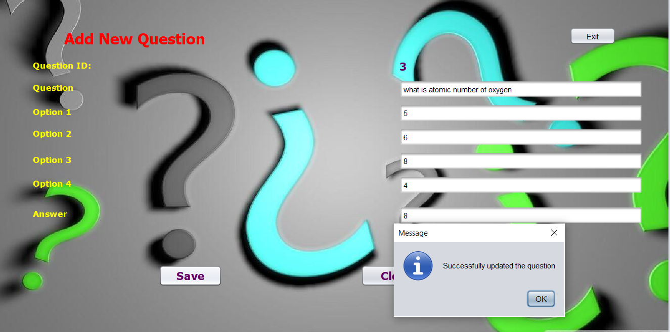

**Fig 4.2.5 Add new question**

**Delete Question :** It allows admin to delete any added question from the exam.

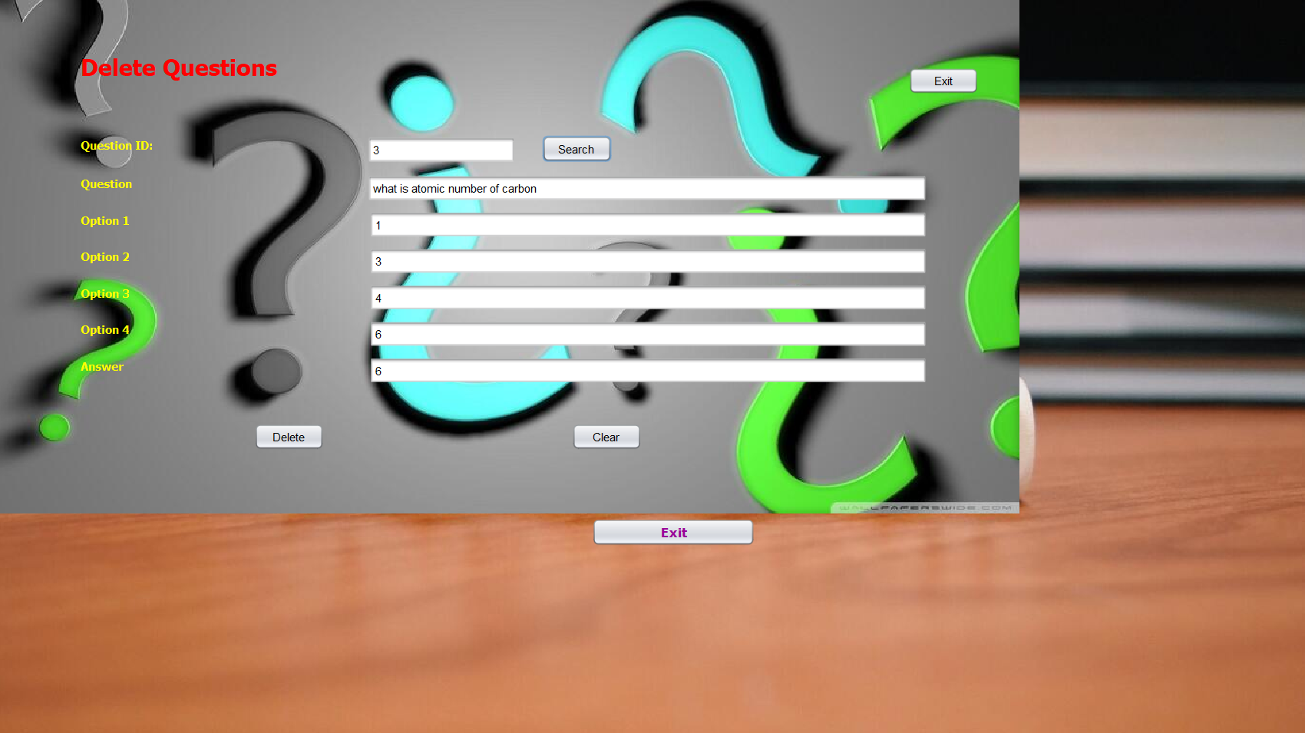

**Fig 4.2.6 Delete Question**

**All Question:** This tab show all the added question in tabular format to admin.

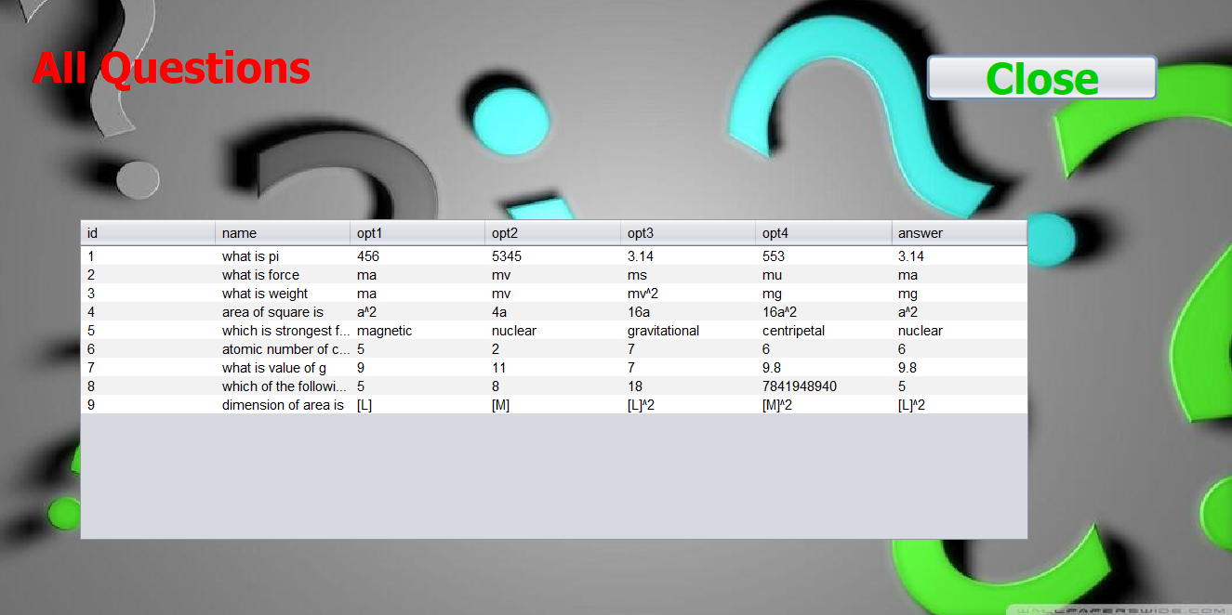

**Fig 4.2.7 All Questions**

**Results:** In this tab admin is able to see result of all the students. The admin can also filter the students by the marks they scored.

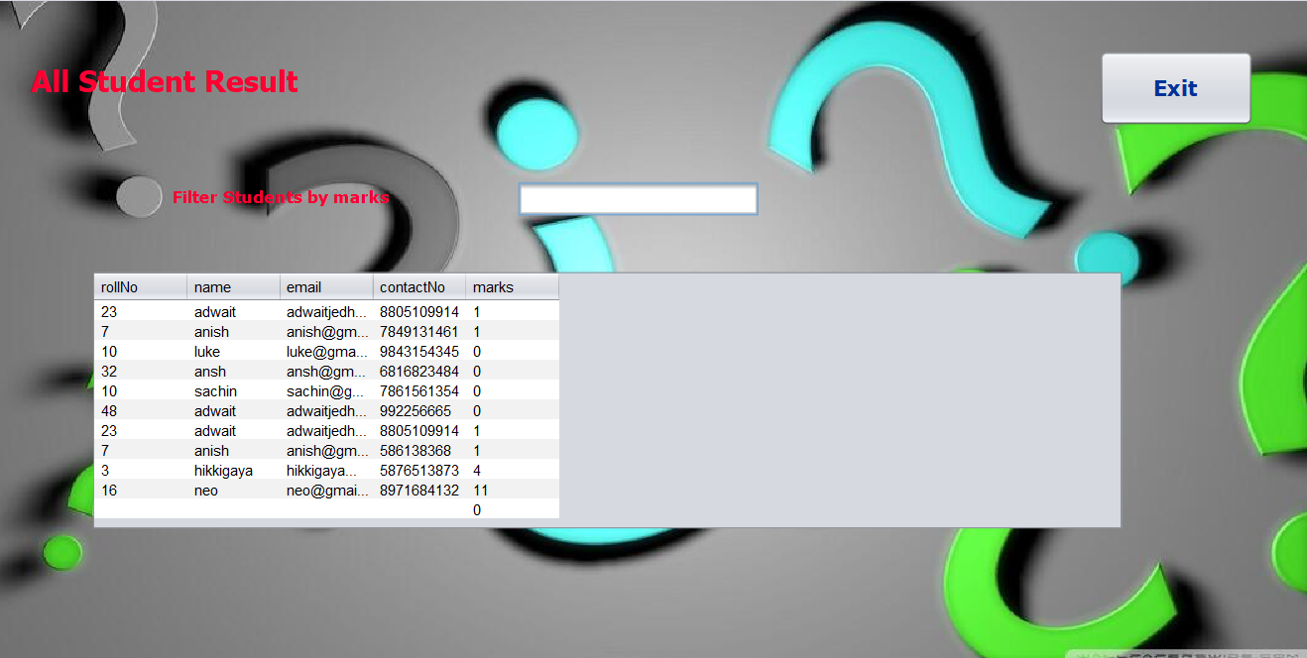

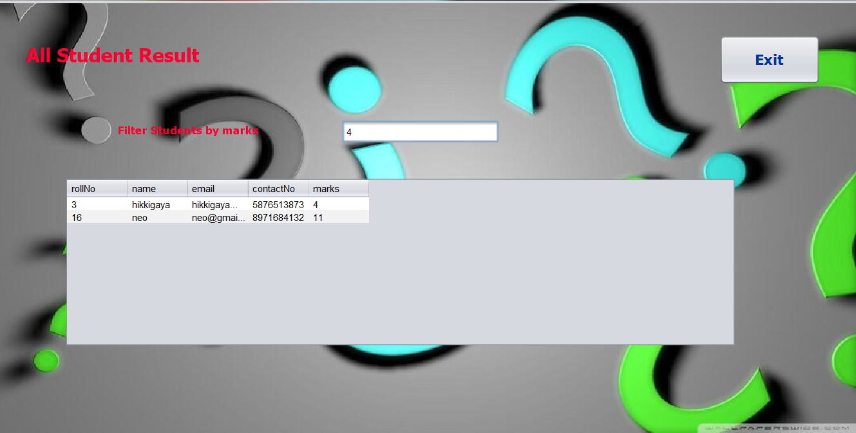

**Fig 4.2.8 Results**

**Student Login Page:** Collects and stores data of all the students giving exam.



**Fig 4.2.3 Student Login Page**

**Quiz Page:** After filling details of students, students are able to attend the exam. We have added timer to test. When the time is up the test is automatically submitted

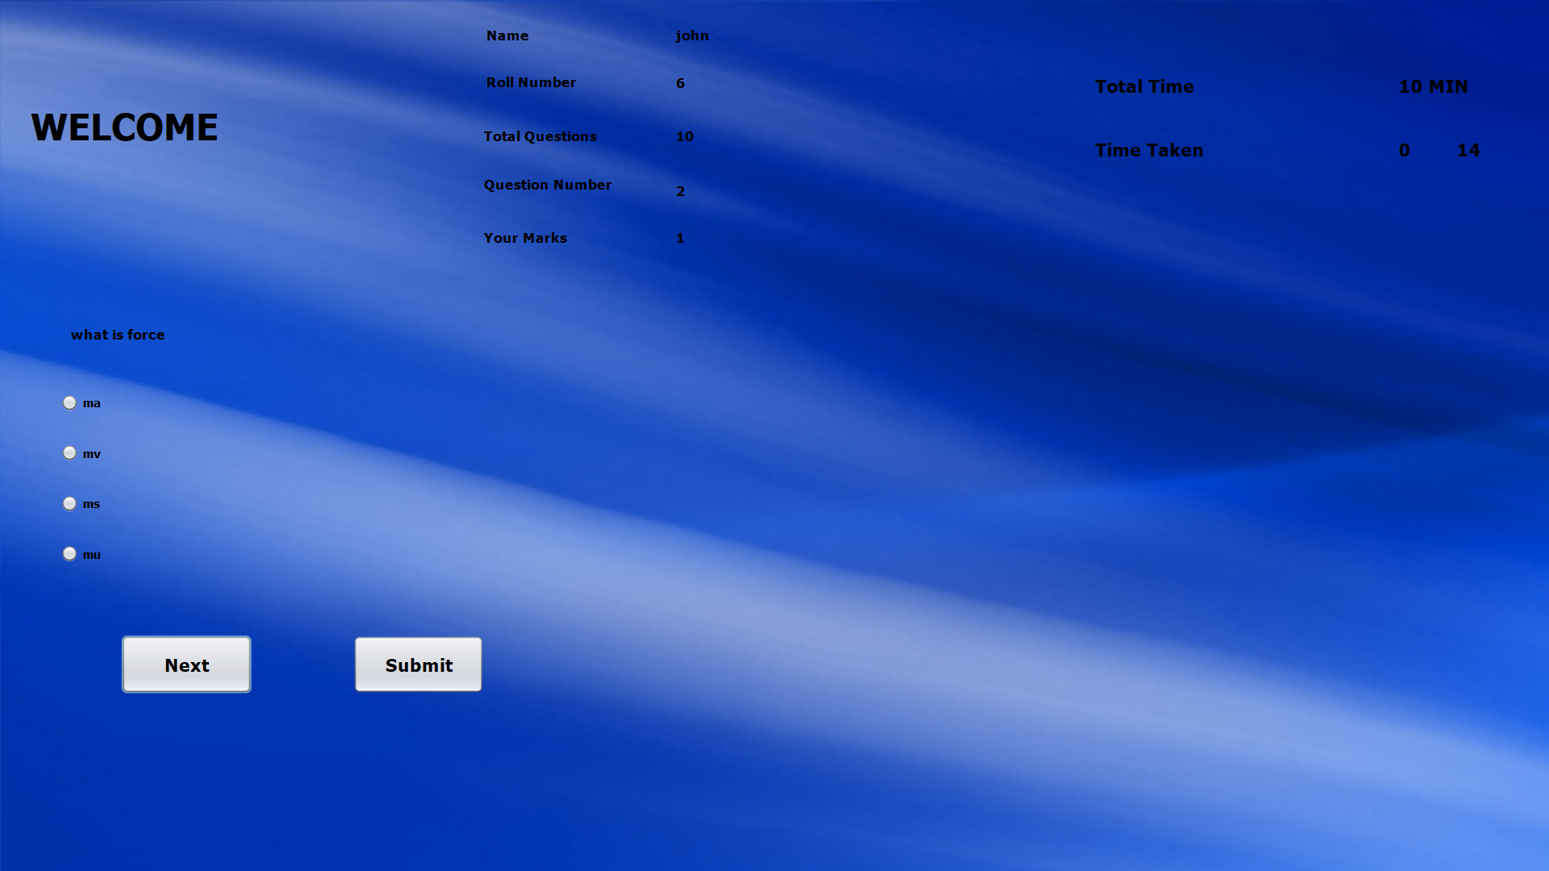

**Fig 4.2.9 Quiz Page**

**Result:** After the paper is submitted marks of students are instantly displayed on Result window.

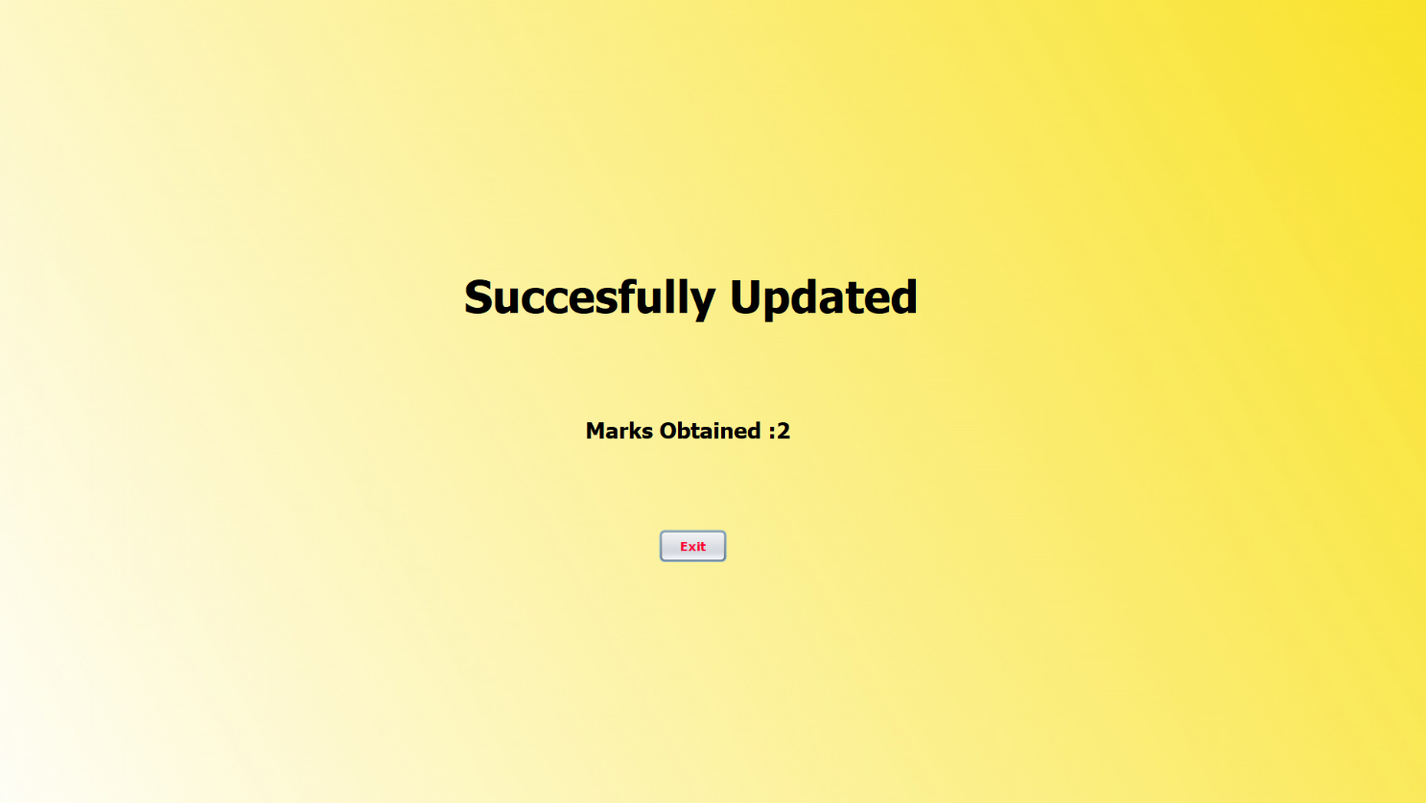

**Fig 4.2.10 Results**

**Chapter 5: Conclusion**

Coming as a solution to the problems of current examination system, this online examination system is subject to modifications and updates as time goes on. This software through its interactive interface can minimize the workload of the educational sector, reduce expense by saving the costs of paper and other such stationary and miscellaneous things which will be impossible to ignore in an offline examination system. Also, in this system there is no need for human labour and time due to the auto timing of each exam. This is a very creative information technology system that can store the record of each student and it can also retrieve it whenever required. As a result of the ability of the system student can write their online examinations within a remote location once connected to the web Uniform Resource Locator (URL).

**Future Scope:**

In future, more upgrades or additional changes can be done to this application to make it more suitable and useful for the target users. Some scopes are:

* User interface (UI) can be improved in future to accommodate global audience by supporting different languages across countries.
* Hosting the database on an online server and putting the application prototype on the Google play store in order to operationalize it for use by whomever may need it. Monitoring of the application downloads and use in order to perform analysis and gauge the effectiveness of a mobile application.
* Pursuit of partnerships with companies and organizations.
* Using Artificial Intelligence, the system can be made more effective as it will be able to process student data on its own and find out students’ weak topics and notify the student to prepare accordingly. They system can also recommend time table, books, topics and subjects to practice.

All these steps can help in making this Java based mini-project more effective and ready to use globally. With proper and more advanced implementations in this mini-project one can make it more user-friendly.

**References**

Anan, J.J., & Graw, M.C. (1991). Population Control’s London. London: Broad Street Press.

Tatomir, B., Rothkrantz, L. (1997). “Dynamic Traffic Routing Using Ant Based Control”. In IEEE International Conference on Systems, Man and Cybernetics, pp. 3970-3975, vol. 4, 2004 .

Douglas, H. (1995). Hypertext Pre-processor. California: Splash Bauer Inc. Jack, W. (2010). Embedded Data Management and Integration. New York Pervasive Software Inc.

John, W., & Joshua, D. (2002). Practical Postgre SQL. California: O ‘Reilly Media.

[www.Youtube.com](http://www.Youtube.com)

<https://www.geniusedusoft.com>